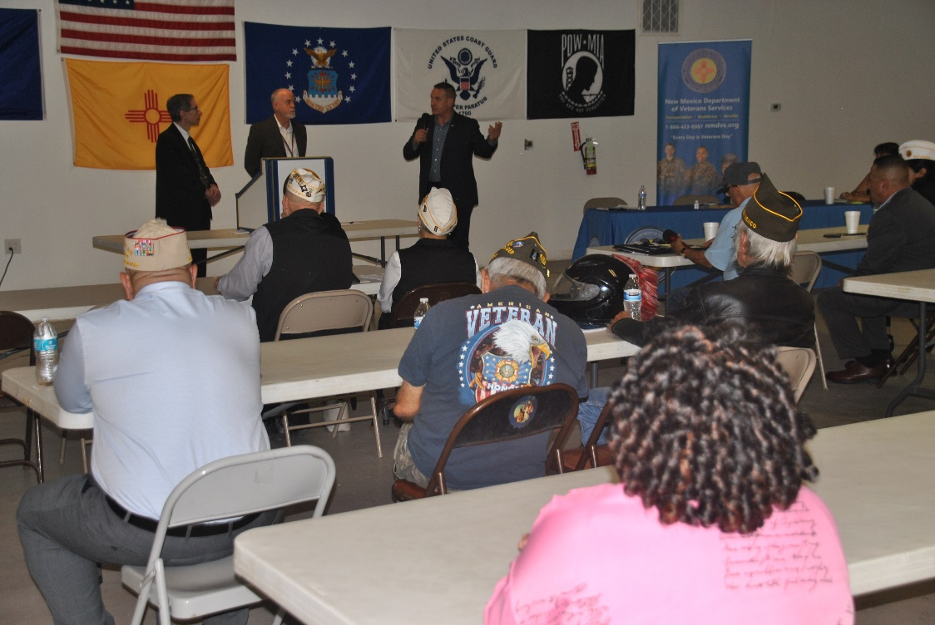
The New Mexico Department of Veterans’ Services (DVS) hosted its latest quarterly Veterans’ Community Briefing on June 12 in Roswell at American Legion Post 28.

DVS Cabinet Secretary Jamison Herrera (top photo/standing at far right) started with introducing newly appointed New Mexico VA Health Care System (NMVAHCS) Director Breton M. Weintraub, M.D., who started his new position the day before (TOP PHOTO: standing @ far left; and below photo).

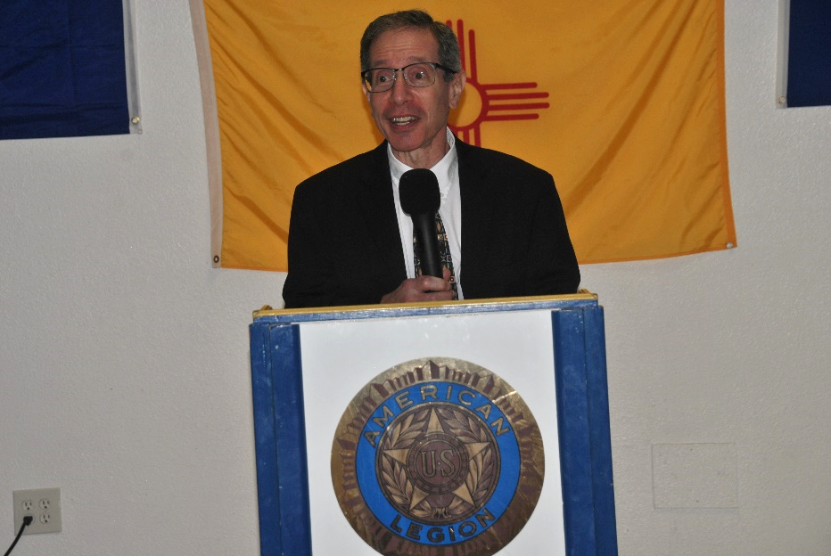

“I’m excited and honored to be your new director of the New Mexico VA Health Care System,” said Dr. Weintraub, who comes to New Mexico from the Fargo, ND, VA Health Care System, where he had been serving as director. “It’s important that we continue to work with the state veterans’ services department, but also the many veterans’ service organizations, to ensure that every veteran gets the best health care possible.”

Secretary Herrera pledged to continue working with the NMVAHCS to continue providing the very best possible care for veterans. Among the issues he highlighted is the need to expand transportation options for veterans beyond the current VA grant-funded Highly Rural Veterans Transportation Program that offers free round-trip rides for to VA medical appointments for veterans in 15 VA-designated “highly rural” counties. Secretary Herrera said DVS received limited funding from the legislature last session to create a statewide program to cover the state’s remaining 18 counties.

The agency has also received funding to increase veteran suicide awareness and prevention, and to help homeless veterans. Details will be released once they have been developed.

Secretary Herrera also talked about two veteran-related ballot initiatives in this November’s general election. One will ask voters to approve raising the state veteran’s property tax exemption from $4,000…to $10,000 off a veterans’ primary residence in New Mexico. The other will ask voters to approve tying the disabled veterans’ property waiver to a veteran’s VA service-connected disability rating.

The secretary stressed the need to learn more about these two measures in the coming months before election day on November 5.

###1

