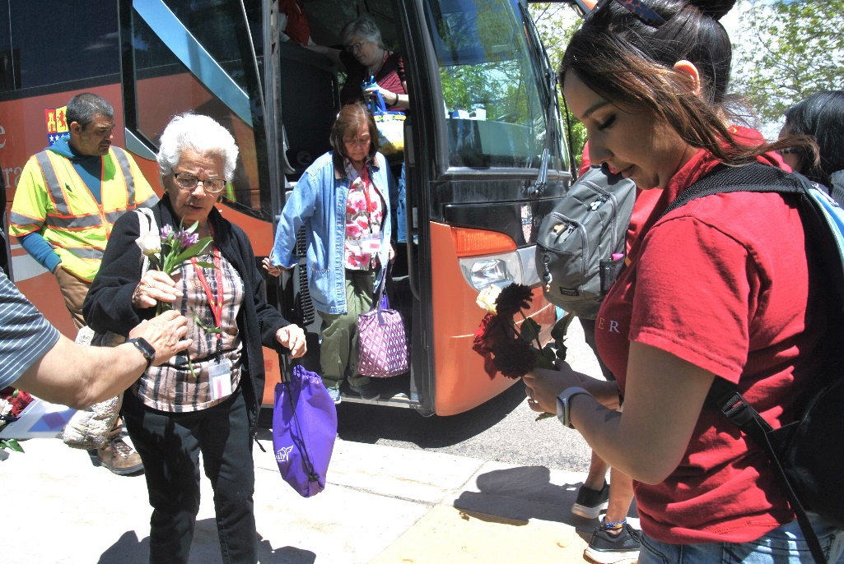
New Mexico Department of Veterans’ Services Deputy Secretary Eric James and State Benefits Director Edward Mendez greeted 40 elderly visitors to the Santa Fe National Cemetery this morning.
The visitors were from several Albuquerque-area senior centers who visited the cemetery courtesy of a pilot program by the Rio Metro Regional Transit’s Rail Runner commuter train and the City of Santa Fe’s Senior Services Division. The trip provides an opportunity for these seniors who can no longer drive or don’t have transportation options to visit the gravesites of loved ones.
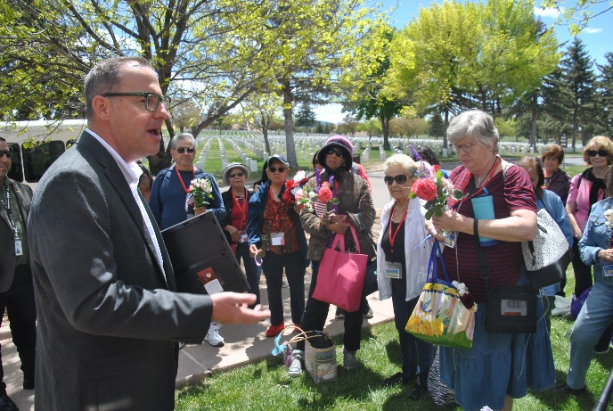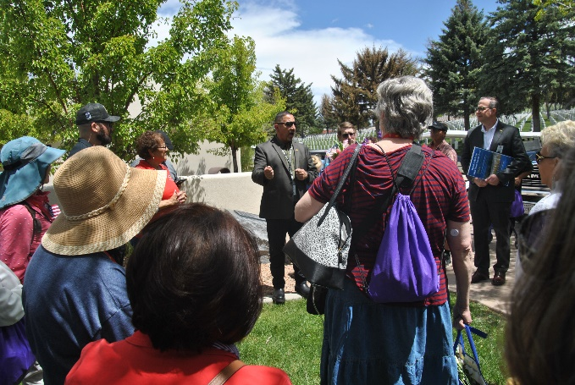
DVS Deputy Secretary James (above left photo) and division director Mendez (above right phot/center, in gray suit) thanked Rail Runner representatives for providing the visitation opportunity, welcomed the visitors to Santa Fe, and reminded them that the nation is forever grateful for the sacrifice and service of their loved ones buried at the cemetery.
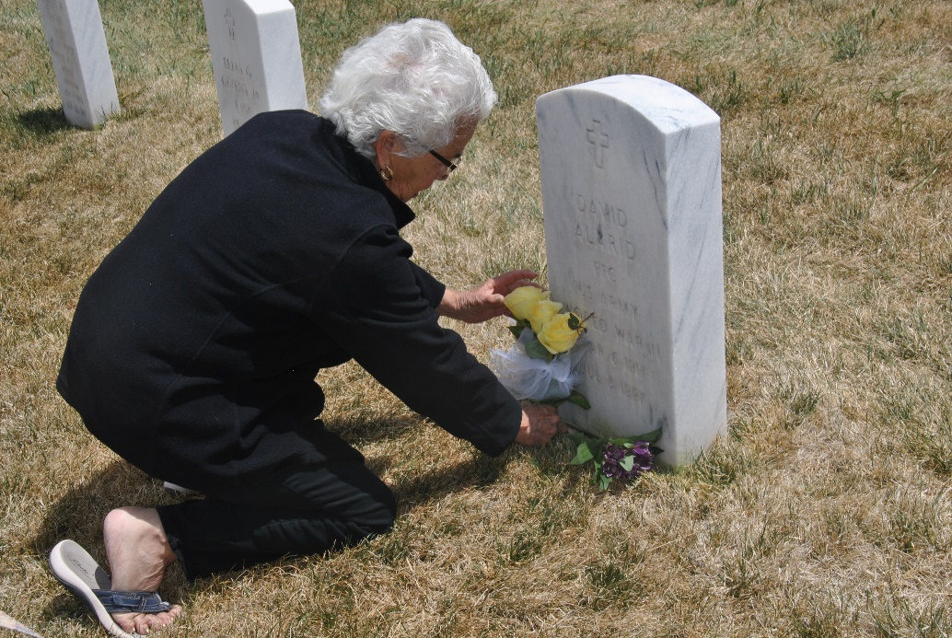
ABOVE PHOTO: Corrine Vigil places flowers on the gravesite of her father, World War II Army Veteran David Alarid

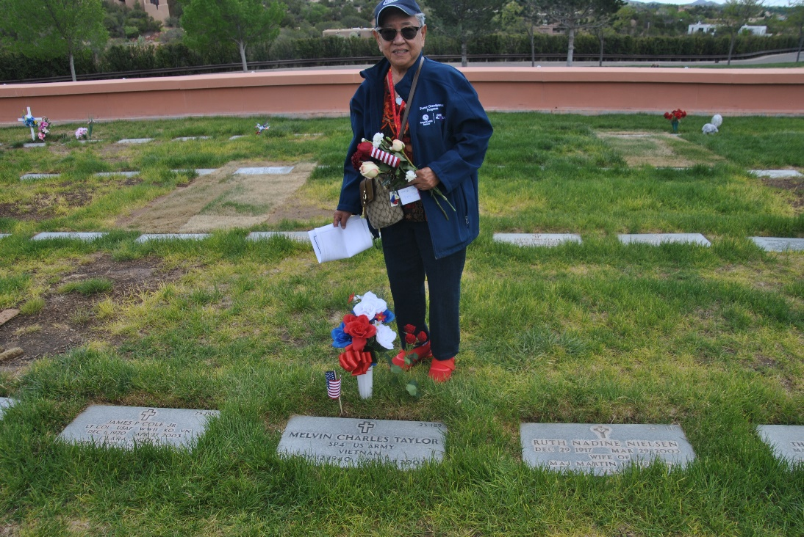
ABOVE PHOTO: Coriz Taylor places flowers and a small American flag at the gravesite of her husband, Vietnam War Army Veteran Melvin Taylor.

